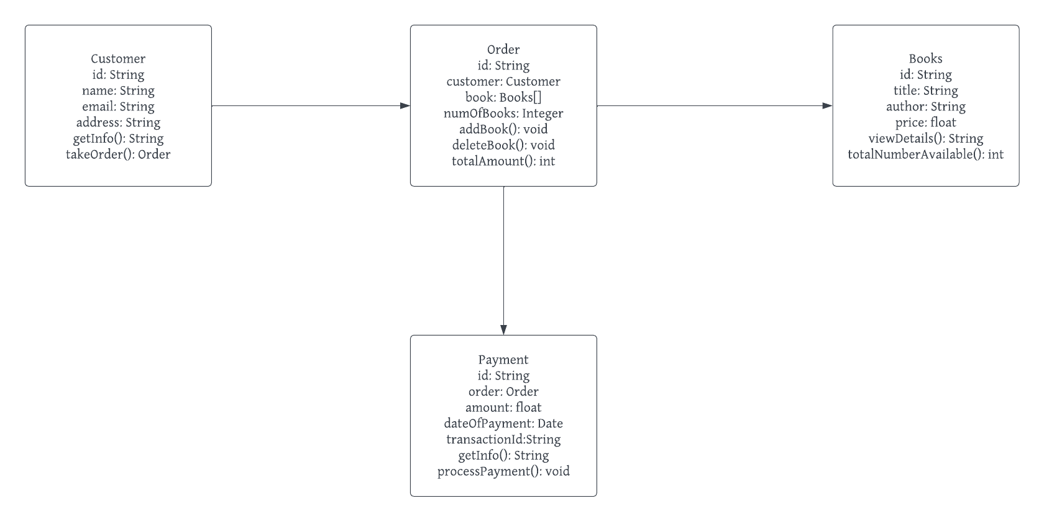

QUESTION 1

**LINK TO PROJECT**

https://lucid.app/lucidchart/c4c2ca32-a2e8-4ea6-ac0a-acb1e159130d/edit?invitationId=inv_20ef7944-c5c9-46ca-908c-04567e03acb8&page=0_0#

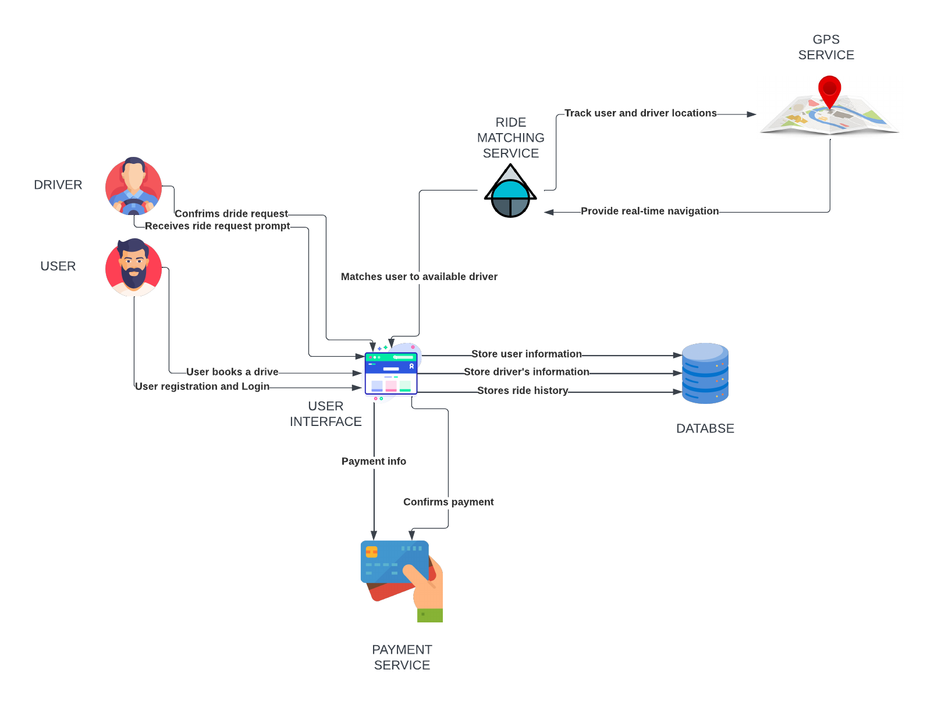

QUESTION 2

**LINK TO PROJECT**

https://lucid.app/lucidchart/ecc85470-56a0-4e27-8e6a-991ba734bbd7/edit?beaconFlowId=7614C61DB2A7A116&invitationId=inv_36089bea-b09e-4b96-aa99-7b50e338a29f&page=0_0#

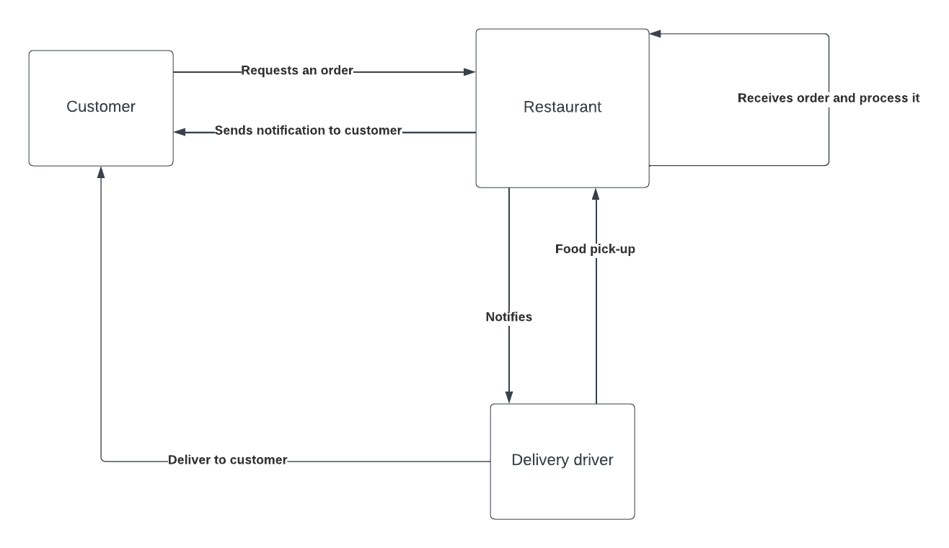

QUESTION 3

**LINK TO PROJECT**

https://lucid.app/lucidchart/c4c2ca32-a2e8-4ea6-ac0a-acb1e159130d/edit?invitationId=inv_20ef7944-c5c9-46ca-908c-04567e03acb8&page=M-A7I_FLS_T0#